**Design & Technology**

**

**Carry out investigations in order to identify problems and needs**

**Materials required for questions**

* Pencil
* Rubber
* Calculator

**Instructions**

* Use black ink or ball-point pen
* Try answer all questions
* Use the space provided to answer questions
* Calculators can be used if necessary
* For the multiple choice questions, circle your answer

**Advice**

* Marks for each question are in brackets
* Read each question fully
* Try to answer every question
* Don’t spend too much time on one question

**Good luck!**

**Q1.** Why do designers carry out investigations before starting a project?

**A** To copy what competitors are doing

**B** To identify problems and understand user needs

**C** To decide how much profit they will make

**Q2.** What is one way a designer can gather useful information?

**A** Guessing what users might want

**B** Asking potential users for feedback

**C** Only looking at old designs

**Q3.** Why might a designer need to change the original brief?

**A** Because they found new problems or better solutions

**B** Because they don’t like the first idea anymore

**C** Because the budget was spent too quickly

**Q4.** What is a good reason to alter a design brief?

**A** User feedback shows the original idea won’t work well

**B** The designer wants to make the project easier

**C** The materials are too expensive, so they give up

**Q5.** The product below is a GPS Sports Watch worn by adult runners to monitor activity and aid training.

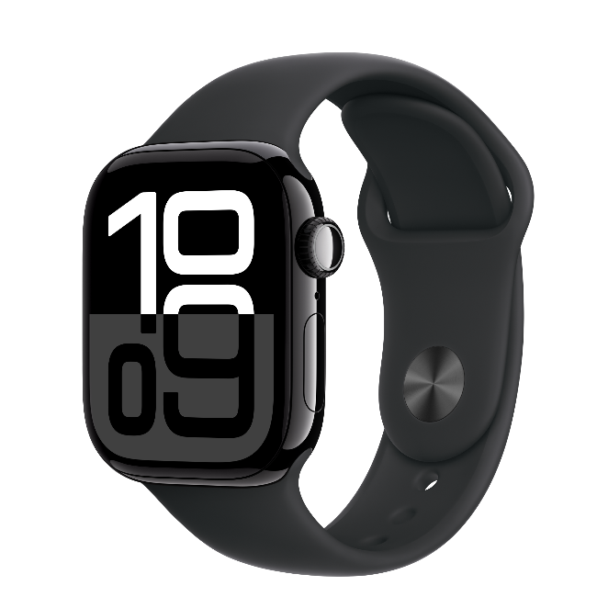

Specification

* Lightweight
* Waterproof (face and strap)
* Rechargeable battery
* Battery lasts up to 3 weeks (10 hours in GPS mode)
* Watch features include; time, date, calendar, alarm, touchscreen and GPS for recording sporting data.

You have been asked to redesign the watch for a child aged between 9 and 11 years old. In order to make the watch more appealing to children it should allow for activities other than running.

Give **four** changes or additions to the original design specification and explain how each would make the watch suitable for the new target market.

You should **not** refer to the colour of the watch in your answer

**Answers**

**Q1**. B

**Q2**. B

**Q3**. A

**Q4**. A

**Q5**.

1 mark for each change or addition to the specification.

1 mark for explanation of why it is important.

Indicative content:

* The product must be smaller in size so that it fits on the wrist of a child aged between 9 and 11 and is not too bulky for them.
* The product should be simple to operate with simple features that are easily accessible to children.
* The product should contain cyber safety features to ensure the child is not put at risk by using it.
* The product should be interesting and engaging for children to encourage them to use it; e.g. by containing logos / images on the strap.
* The product must have tracking feature so parents can track children’s whereabouts.
* The product could have mini-games to provide entertainment for children.
* Greater range of strap adjustment because children likely to grow significantly between ages of 9 and 11.